Handheld intelligent command box QC-P1

Product Overview
The QC-P1 series portable intelligent command box is an integrated wireless emergency command terminal operating on Android and Linux systems, featuring 5G public network connectivity, HD video encoding/decoding, intelligent recognition capabilities, and large-screen display. It facilitates seamless emergency command operations with "uninterrupted communication, real-time field response, comprehensive data availability, and precise command execution," making it widely applicable across public security, power supply, emergency management, firefighting, and related sectors.
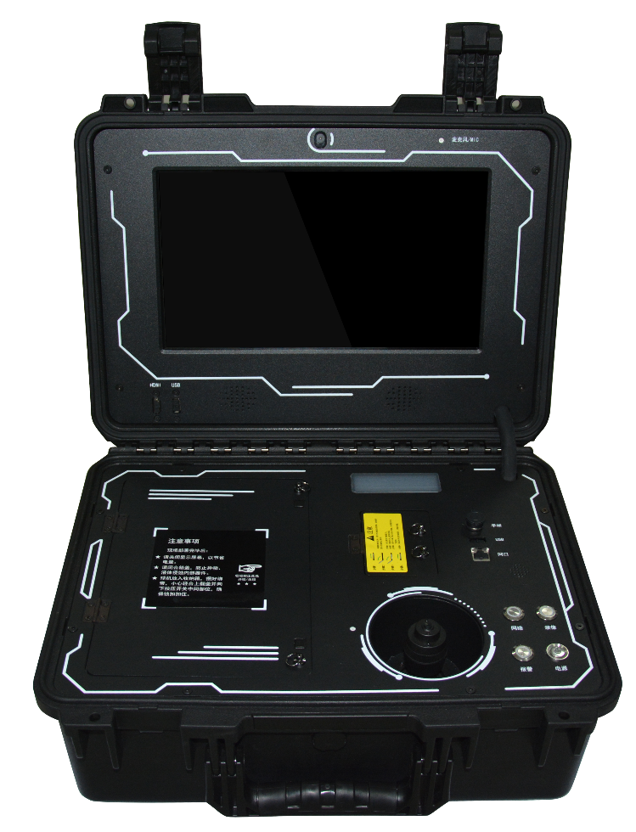

functional characteristics
14-inch FHD display with touchscreen
Face detection Safety helmet detection
20Ah built-in lithium battery
8-megapixel HD camera
IP67 protection rating
Embedded + Android dual operating systems
H.264/H.265 video compression encoding
Dual TF cards, each with 256 GB
Multiple hardware ports for external sensors
Beidou/GPS dual-mode positioning

Specification Parameters
project | technical parameter
operating system | Dual system: Android + Linux
Built-in camera | 8-megapixel high-definition camera
External camera | Standardly equipped with a 1-channel aerial head-mounted PTZ camera
fixed position | Dual-mode positioning with BeiDou and GPS, featuring AGPS
video coding | H.265/H.264
video in | 1*Air interface, 1*HDMI
Video Output | HDMI
Media Stream Type | Real-time stream, storage stream
Image frame rate | Maximum 30 FPS
Audio Encoding | AAC/AMR/G.711
Audio Mode | Built-in speaker/presenter with hands-free microphone support
key | Power supply, video recording, network, alarm
Cloud Platform | 4D optical joystick for controlling pan-tilt cameras
display screen | 14-inch capacitive touchscreen with multi-touch support and a resolution of 1920×1080
situation display | OLED small display showing network status, recording status, battery level, and other information
memory | Supports two TF card slots, with a maximum capacity of 256 GB per card (customizable hard disk storage available)
SIM Card | Supports up to 3 SIM cards and 4G, with expandable 5G support
Other networks | Supports RJ45 network ports and Wi-Fi
PDA | support
AI characteristic | Face detection, helmet detection (optional)
power supply mode | Powered by a 20Ah lithium battery, with a working duration of ≥8 hours.
Power Source Characteristics | Use a 12.6V/5A aviation power adapter
levels of protection | IP67 (closed enclosure)
working temperature | -10℃~+55℃
weight | 13 kg (whole unit)

application scenarios

Emergency Rescue On-Site Command
Designed for emergency rescue operations during sudden disasters such as earthquakes, floods, fires, and landslides. Serving as a mobile command hub at the front line, it enables video transmission, two-way intercom communication, and large-screen visual dispatching via 5G/WiFi, providing critical support for on-site command decision-making and coordination with rear units.

The frontline police forces carry out law enforcement and case investigations.
Designed for case handling, arrest operations, checkpoint inspections, and emergency response scenarios. Its integrated portable design facilitates rapid deployment, enabling real-time transmission of on-site footage, identity verification, and AI-powered intelligent analysis to meet the demands of mobile command, on-site evidence collection, and remote consultation for frontline law enforcement.

Fire and Rescue Operations Command
Suitable for fire rescue, emergency disaster relief, hazardous chemical disposal, and other firefighting scenarios. Featuring IP67 high protection rating, extended battery life, and stable dual-system operation, it can receive real-time video feeds from front-end devices, enabling voice dispatch, video evidence recording, and command issuance.

Emergency Command for Power Repair Operations
Designed for scenarios such as power line faults, substation emergency repairs, field construction, and grid emergency response. It eliminates the need for on-site network connectivity, enabling rapid establishment of temporary command posts, real-time monitoring of construction progress, remote operational guidance, and full-process video recording to ensure safe and efficient repair operations.

Security Command for Large Events
Ideal for densely populated venues such as concerts, sporting events, exhibitions, and gatherings. Functioning as a mobile command terminal, it enables multi-screen surveillance, crowd monitoring, anomaly alerts, voice-based dispatching, and unified coordination of security forces to enhance on-site response efficiency.

On-site traffic management and dispatching
For use in traffic accidents, road control, construction traffic management, and highway rescue operations. enables rapid on-site deployment, real-time transmission of accident footage and video evidence collection, supports real-time coordination with command centers, and enhances the standardization of traffic emergency response procedures.

Field Operations/Exploration Command
Designed for use in environments without power grids or electricity, such as wilderness exploration, forestry patrols, water resource surveys, and border inspections. Equipped with a high-capacity built-in battery and supporting 5G/Beidou positioning, it can independently perform video transmission, data recording, positioning navigation, and on-site command operations.

Construction Site/Mine Safety Supervision
Designed for on-site supervision in construction sites, mining operations, and hazardous chemical facilities. AI-powered intelligent detection identifies violations such as improper helmet wear and unauthorized access to designated areas, enabling real-time monitoring, voice alerts, and remote command to enhance workplace safety management.

Emergency Drill/Practical Training Assessment
Applicable for emergency drills, fire drills, security training, and skill assessments. The entire process is recorded with synchronized video transmission, real-time scoring, and command, ensuring the drill process is observable, recordable, and traceable, thereby enhancing drill effectiveness.

Temporary command center established
This solution is suitable for emergency scenarios involving power outages, network disruptions, or lack of infrastructure. It enables rapid deployment of an integrated temporary command hub that combines video surveillance, network connectivity, storage capabilities, positioning systems, and dispatch functions, meeting the emergency requirements of "uninterrupted communication, real-time on-site access, comprehensive data availability, and precise command coordination."

